Dear sir/madam,

On behalf of the Head school of Pharmacy, Universitas Muhammadiyah Yogyakarta, we want to inform you about our precious agenda named “The 4th International Pharmacy Summer School (IPSS) 2017”. This agenda have been held from 2014 and ran successfully with many participants from Indonesia and overseas joined to this event.

By this letter, we invite your students to come to Indonesia for 12 days to join this event, on 31st July until 12th August. We attach our registration form, booklet and poster below. Please share and inform this event to your students and colleagues to join this event.

For more information, you can find us on ipss@umy.ac.id

We look forward for your response at your earliest convenience.

Thank you.

Yours faithfully,

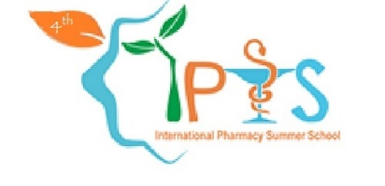The Chairman of IPSS 2017

Faculty of Medicine and Health Sciences

University of Muhammadiyah Yogyakarta

Jl. Ringroad Barat Daya, Tamantirto

Yogyakarta 55183, Indonesia

Website : ipss.umy.ac.id

Email : ipss@umy.ac.id